APPLICATION OF DECIMAL TO BINARY CONVERSION

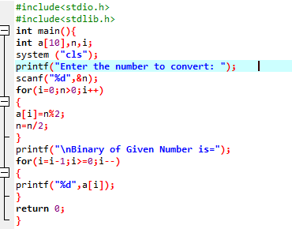

OUTPUT

